Assignment -4

|  |  |
| --- | --- |
| Assignment Date | 19 October 2022 |
| Student Name | MUTHU VIGNESH |
| Maximum Marks | 2 Marks |

Question-1:

Write code and connections in wokwi for ultrasonic sensor.

Whenever distance is less than 100cms send “alert” to IBM cloud and display in device recent events.

Code:

Wokwi Link:<https://wokwi.com/projects/346140569842483796>

#include <WiFi.h>

#include <PubSubClient.h>

#include "DHT.h"

#define TRIGGER 2

#define ECHO 15

#define sound 0.034

DHT dht (DHTPIN, DHTTYPE); int distance; void callback(char* subscribetopic, byte* payload, unsigned int payloadLength);

//-------credentials of IBM Accounts------

#define ORG "85br02"

#define DEVICE_TYPE "gas_leakage_system"

#define DEVICE_ID "gas_leakage_device"

#define TOKEN "_NAMljLh@&H&(w6*Ts"

String data3;

//-------- Customise the above values -------- char server[] = ORG ".messaging.internetofthings.ibmcloud.com"; char publishTopic[] = "iot-2/evt/Data/fmt/json"; char subscribetopic[] = "iot-2/cmd/test/fmt/String"; char authMethod[] = "use-token-auth"; char token[] = TOKEN; char clientId[] = "d:" ORG ":" DEVICE_TYPE ":" DEVICE_ID; //-----------------------------------------

WiFiClient wifiClient;

PubSubClient client(server, 1883, callback ,wifiClient); void setup()

{

Serial.begin(115200); pinMode(TRIGGER, OUTPUT); pinMode(ECHO, INPUT);

dht.begin(); delay(10); Serial.println(); wificonnect(); mqttconnect();

}

void loop()

{

digitalWrite(TRIGGER, HIGH); delayMicroseconds(10); digitalWrite(TRIGGER, LOW); int time=pulseIn(ECHO,HIGH); distance=(time*sound)/2; Serial.print("Distance:");

Serial.print(distance); Serial.println("cms"); if(distance<100){

//PublishData(distance);

}

delay(1000); if (!client.loop()) { mqttconnect();

}

}

/*.....................................retrieving to Cloud...............................*/

void PublishData(int d) { mqttconnect();

String payload = "{\"message\":alert}";

Serial.print("Sending payload: ");

Serial.println(payload);

if (client.publish(publishTopic, (char*) payload.c_str())) {

Serial.println("Publish ok");

} else {

Serial.println("Publish failed");

}

}

void mqttconnect() { if (!client.connected()) {

Serial.print("Reconnecting client to "); Serial.println(server); while (!!!client.connect(clientId, authMethod, token)) { Serial.print("."); delay(500);

}

initManagedDevice();

Serial.println();

}

}

void wificonnect()

{

Serial.println();

Serial.print("Connecting to "); WiFi.begin("Wokwi-GUEST", "", 6); while (WiFi.status() != WL_CONNECTED) { delay(500);

Serial.print(".");

}

Serial.println("");

Serial.println("WiFi connected");

Serial.println("IP address: ");

Serial.println(WiFi.localIP());

}

void initManagedDevice() { if (client.subscribe(subscribetopic)) { Serial.println((subscribetopic));

Serial.println("subscribe to cmd OK");

} else {

Serial.println("subscribe to cmd FAILED");

}

}

void callback(char* subscribetopic, byte* payload, unsigned int payloadLength)

{

Serial.print("callback invoked for topic: "); Serial.println(subscribetopic); for (int i = 0; i < payloadLength; i++) { data3 += (char)payload[i];

}

Serial.println("data: "+ data3); data3="";

}

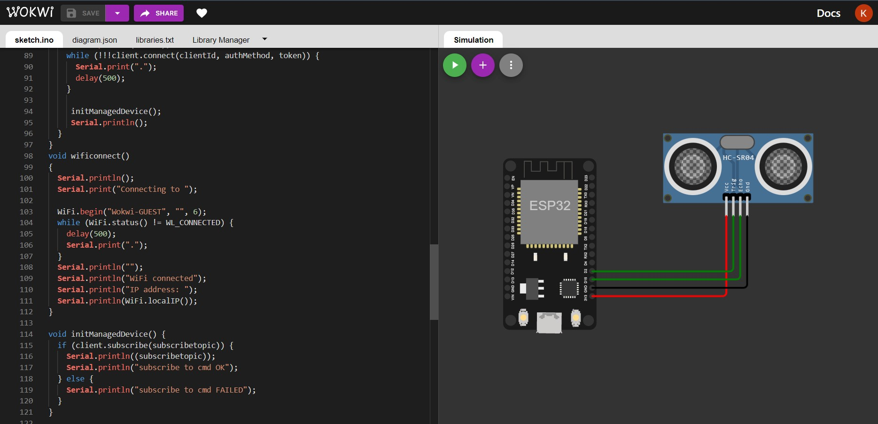

# Wokwi Platform

https://wokwi.com/dashboard/projects

Device Recent Events

